Customer Engagement and Product Utilization Analytics for Retention Strategy: A Behavioral and Relationship-Based Framework for the Banking Sector
Research Project Report
Submitted by: Pummy Gupta

B.Tech (Artificial Intelligence & Data Science) — Final Year
Prepared for: Unified Mentor — Machine Learning Internship

Table of Contents
Table of Contents 1
Title 1
Abstract 1
Keywords 1
1. Introduction 1
2. Background and Motivation 1
3. Problem Statement 1
4. Research Objectives 1
5. Literature Review 1
5.1 Predictive Modeling Approaches 1
5.2 Explainability and Causal Interpretation 1
5.3 Engagement and Relationship-Marketing Perspectives 1
5.4 Summary of the Literature 1
6. Research Gap 1
7. Dataset Description 1
8. Research Methodology 1
8.1 Data Preparation 1
8.2 Threshold and Segment Definition 1
8.3 Compound Segment Definitions 1
8.4 KPI Computation 1
8.5 Analytical Caution 1
8.6 Visualization 1
8.7 Dashboard Implementation Evidence 1
9. Exploratory Data Analysis 1
10. Customer Engagement Analysis 1
11. Product Utilization and Churn Analysis 1
11.1 Churn by Number of Products 1
11.2 Interaction Between Product Utilization and Engagement 1
12. High-Value Customer Risk Analysis 1
12.1 High-Balance Customers and Engagement 1
12.2 High-Value Risk Segment 1
12.3 High-Value Risk Segment by Product Count 1
12.4 High-Value Risk Segment by Geography 1
13. Relationship Strength Analysis 1
14. Key Performance Indicators 1
15. Results and Discussion 1
16. Business Recommendations 1
17. Limitations 1
18. Future Scope 1
19. Conclusion 1
References 1

Title
Customer Engagement and Product Utilization Analytics for Retention Strategy: A Behavioral and Relationship-Based Framework for the Banking Sector

Abstract
Customer retention continues to be one of the most pressing operational concerns for retail banks, since the cost of retaining an existing customer is widely regarded as lower than the cost of acquiring a new one. Most published churn studies concentrate on maximizing the predictive accuracy of machine learning classifiers, while comparatively little attention is paid to building an interpretable, business-facing framework that a retention team could act on directly. This study addresses that gap by analyzing a banking dataset of 10,000 customers across fourteen variables to examine how customer engagement, product utilization, financial value, and relationship depth relate to observed churn behavior. Rather than relying on demographic profiling, the analysis is deliberately built around behavioral and relationship indicators such as account activity status, number of products held, balance level, and their combined effects.
The dataset shows an overall observed churn rate of 20.37 percent and a retention rate of 79.63 percent. Customer engagement emerged as a strong differentiator: inactive customers churned at 26.85 percent compared with 14.27 percent for active customers, a gap of 12.58 percentage points, meaning inactive customers show close to 1.88 times the churn observed among active customers. Product utilization showed a more complex, non-monotonic pattern, with two-product customers showing the lowest observed churn (7.58 percent) among the major groups, while the very small three- and four-product segments showed disproportionately high churn (82.71 percent and 100 percent respectively) that must be interpreted with caution given their limited sample sizes. Combining engagement with product count revealed that inactive single-product customers churn at 36.65 percent, more than six times the rate of active two-product customers (5.56 percent). A defined high-value risk segment — high-balance, inactive customers aged 44 or above — comprising 311 customers (3.11 percent of the base) showed an observed churn rate of 64.95 percent, 44.58 percentage points above the overall rate, with Germany showing the highest within-segment churn among the three geographies studied. Conversely, a relationship-strength segment of active, two-product customers (2,446 customers, 24.46 percent of the base) showed 94.44 percent retention, 14.81 percentage points above the overall base and expressed as a Relationship Strength Index of 118.60.
The paper proposes a behavioral and relationship-based retention analytics framework built around a defined set of key performance indicators — including a High-Value Risk Churn Rate, a Credit Card Stickiness Score, and a Relationship Strength Index — that together allow a bank to prioritize retention resources toward the customer segments where intervention is likely to matter most. The study makes no causal claims and explicitly flags segments with small sample sizes; its contribution lies in translating descriptive and diagnostic analytics into an operational lens for retention decision-making rather than in producing a new predictive algorithm.

Keywords
Customer Churn; Customer Retention; Customer Engagement; Product Utilization; Relationship Strength; Banking Analytics; Behavioral Segmentation; Key Performance Indicators; High-Value Customer Risk.

1. Introduction
Retail banks operate in an environment where customers have an increasing number of alternatives for where they hold their deposits, cards, and loans. In this setting, customer churn — the discontinuation of a customer's relationship with a bank — has a direct and measurable effect on revenue, since replacing a lost customer typically costs more than retaining an existing one. Banks have therefore invested heavily in analytics capabilities that can help identify which customers are at risk of leaving and why, so that retention resources can be directed where they are likely to have the greatest effect.
A large part of the existing literature on this problem approaches churn primarily as a classification task, applying machine learning or deep learning models to a customer dataset and reporting accuracy, precision, recall, or F1-score for the resulting model (Vu, 2023; de Lima Lemos et al., 2022). While this line of work is valuable for building automated early-warning systems, it does not always translate directly into a framework that a retention or relationship-management team can use to understand which behaviors matter and why. This project takes a complementary, descriptive and diagnostic-analytics approach: rather than optimizing a predictive model, it systematically examines how a small number of behavioral and relationship variables — engagement status, product count, account balance, and their combinations — relate to the observed rate of churn in a dataset of 10,000 banking customers.
The remainder of this paper is organized as follows. Section 2 discusses the background and motivation for a behavior-first approach to retention analytics. Section 3 states the problem being addressed, and Section 4 lists the research objectives. Section 5 reviews related literature, and Section 6 identifies the specific gap this study addresses. Section 7 describes the dataset, and Section 8 explains the methodology used. Sections 9 through 13 present the exploratory, engagement, product, high-value risk, and relationship-strength analyses in turn. Section 14 defines the key performance indicator framework used throughout the paper. Sections 15 through 19 discuss the results, propose business recommendations, state the limitations of the study, outline future scope, and conclude the paper.

2. Background and Motivation
Customer retention in banking has traditionally been approached through relationship marketing, where the strength, length, and depth of the customer-bank relationship are treated as levers that influence how loyal a customer remains (Al-Wugayan, 2021). More recently, banks have combined this relationship view with data-driven decisioning, using transactional and behavioral data to identify at-risk customers earlier and more precisely than relationship managers could on their own. Research on social customer relationship management has similarly shown that customer engagement plays a mediating role in the link between how a bank manages its customer relationships and the long-term value it derives from those customers (Thach et al., 2025).
At the same time, most published churn-analytics work in the banking domain has been framed as a prediction problem, applying ensemble methods, deep learning, or hybrid resampling techniques to maximize classification performance on historical churn labels (Alizadeh et al., 2023; Bharathi et al., 2022; Vu, 2024). This body of work demonstrates that behavioral variables — particularly account activity and product holdings — are consistently among the strongest predictors of churn, but it typically reports these findings as feature-importance scores inside a larger model rather than as directly interpretable business metrics. The motivation for the present study is to take these same categories of behavioral variables and analyze them descriptively and diagnostically, producing a set of transparent, calculable KPIs that a retention team could monitor on an ongoing basis without needing to interpret a machine learning model.
A second motivation is the observation, echoed in relationship-banking literature, that not all customers warrant equal retention effort. Segmenting customers by their financial value in combination with their behavioral engagement allows a bank to concentrate retention spending on customers who are both valuable and at risk, rather than distributing effort uniformly across the customer base (Al-Wugayan, 2021).

3. Problem Statement
Retail banks generate large volumes of customer data describing account activity, product holdings, balances, and demographic attributes, yet much of the retention-analytics literature converts this data into a single predictive score without clearly separating which behavioral factors drive that score or how strongly. This makes it difficult for a bank's retention team to translate a model's output into a concrete, prioritized action plan. In addition, demographic profiling — segmenting customers by age, gender, or geography alone — provides limited actionable insight, since a bank generally cannot change a customer's demographic attributes, but it can influence engagement, cross-sell strategy, and relationship depth.
The problem addressed in this study is therefore twofold. First, how do behavioral and relationship indicators — specifically account activity status, number of products held, and their interaction — relate to observed customer churn in a real banking dataset, and how large are these effects in practical terms? Second, how can these relationships be combined with financial value (account balance) and geographic context to identify a small, high-priority segment of customers where retention intervention would be expected to have the greatest impact, while avoiding overstated conclusions from segments that are too small to generalize from.

4. Research Objectives
The specific objectives of this study are as follows:
- To quantify the overall observed churn and retention rates in the dataset and establish them as a baseline for comparison across segments.
- To analyze the relationship between customer engagement (active versus inactive account status) and observed churn.
- To analyze the relationship between product utilization (number of products held) and observed churn, while explicitly accounting for the small sample sizes of the three- and four-product segments.
- To examine the combined, interaction effect of engagement and product utilization on churn.
- To define and analyze a high-balance customer segment and a more narrowly defined high-value risk segment, including its composition by product count and geography.
- To define and analyze a relationship-strength segment representing customers with both high engagement and moderate product depth.
- To propose a compact set of key performance indicators that operationalize these findings for ongoing retention monitoring.
- To translate the observed findings into business recommendations while being explicit about the limitations of an observational, cross-sectional dataset.

5. Literature Review
The literature on bank customer churn can be broadly grouped into three streams: predictive modeling studies that apply machine learning or deep learning to classify churners, studies that focus on explainability and causal interpretation of churn drivers, and relationship-marketing studies that examine engagement and relationship strength as constructs in their own right.

5.1 Predictive Modeling Approaches
A substantial share of recent work treats churn prediction as a supervised classification problem. Vu (2023) proposed a two-level stacked deep learning architecture combining three neural network base learners with a logistic regression meta-learner, reporting accuracy above 96 percent on a bank churn dataset, and later extended this line of work with a combined machine learning ensemble across four base classifiers to further improve prediction performance (Vu, 2024). Alizadeh et al. (2023) combined structured customer records with unstructured survey-style data in a hard-and-soft data fusion model published in IEEE Access, showing that supplementing transactional variables with softer relationship indicators can meaningfully improve churn classification. Bharathi et al. (2022) focused specifically on the youth segment of retail banking customers and built an ensemble model to predict churn within that subgroup, illustrating that churn drivers can vary meaningfully across customer segments rather than being uniform across the whole base. Al-Najjar et al. (2022) applied similar machine learning techniques specifically to credit-card customer churn, again finding that behavioral and account-usage variables were the strongest contributors to churn risk.

5.2 Explainability and Causal Interpretation
A smaller but growing stream of work has emphasized moving beyond raw predictive accuracy toward interpreting why customers churn. Rudd et al. (2022) examined churn causal analysis in financial institutions by restraining the high-dimensional feature space typically used in churn models, arguing that a more constrained, interpretable feature set produces insights that are more directly usable by decision-makers than a black-box model. This concern for interpretability over raw accuracy is closely aligned with the descriptive and diagnostic approach taken in the present study, which deliberately avoids building a predictive classifier in favor of transparent, calculable segment-level metrics.

5.3 Engagement and Relationship-Marketing Perspectives
Outside the machine learning literature, relationship-marketing research has long examined the strength of the customer-bank relationship as a determinant of retention outcomes. Al-Wugayan (2021) investigated how the length, depth, and width of a customer's banking relationship influence perceived relationship quality and downstream relational outcomes in retail banking, finding that relationship strength dimensions meaningfully shape how customers evaluate their bank relationship. More recently, Thach et al. (2025) studied social customer relationship management in banking and found that customer engagement mediates and moderates the link between relationship management practices and customer lifecycle value, reinforcing engagement as a construct that sits between what a bank does and the value it ultimately retains from a customer relationship. These relationship-marketing findings motivate treating engagement and product depth, rather than static demographic attributes, as the primary lens for the present study's segmentation.

5.4 Summary of the Literature
Across both streams, behavioral variables — account activity, product holdings, and account balance — consistently emerge as influential factors associated with churn, whether they are used as features inside a predictive model or as constructs inside a relationship-marketing study. However, the predictive-modeling literature tends to report these factors as importance scores inside a larger, less transparent model, while the relationship-marketing literature tends to study engagement and relationship strength conceptually, without necessarily quantifying them against a specific transactional dataset. The present study sits between these two streams, using the same categories of behavioral variables studied in the predictive literature, but analyzing them descriptively and diagnostically in the spirit of the interpretability concerns raised in the causal-analysis literature.

6. Research Gap
Three gaps can be identified from the literature reviewed above. First, the large majority of banking churn studies are oriented toward maximizing classifier performance, which, while useful for automated flagging, does not by itself produce a transparent framework that a retention team can use to understand which specific behaviors and combinations of behaviors are associated with the highest observed churn. Second, few studies explicitly combine engagement, product depth, financial value, and geography into a single, layered segmentation that identifies a narrow high-value risk group, rather than analyzing these dimensions separately. Third, published studies rarely draw explicit attention to the danger of overstating findings from small subgroups — such as customers holding three or four products in the present dataset — even though such subgroups can produce dramatic-looking churn rates that are not statistically reliable given their limited size.
This study addresses these gaps by building a descriptive and diagnostic behavioral framework — rather than a predictive classifier — that layers engagement, product utilization, financial value, relationship strength, and geography into a single set of interpretable key performance indicators, while explicitly flagging segments where the sample size warrants caution in interpretation.

7. Dataset Description
The analysis is based on a banking customer dataset containing 10,000 customer records and 14 variables. The target variable, Exited, indicates whether a customer churned (1) or was retained (0) during the observation period. Table 1 summarizes the variables used in the analysis.
Variable | Description
Year | Observation year associated with the customer record
CustomerId | Unique identifier assigned to each customer
Surname | Customer surname (identifying field, not used analytically)
CreditScore | Customer's credit score
Geography | Country of the customer's bank branch (France, Germany, Spain)
Gender | Customer gender
Age | Customer age in years
Tenure | Number of years the customer has held an account with the bank
Balance | Customer's account balance
NumOfProducts | Number of bank products held by the customer (1 to 4)
HasCrCard | Whether the customer holds a credit card (1 = Yes, 0 = No)
IsActiveMember | Whether the customer is an active member (1 = Active, 0 = Inactive)
EstimatedSalary | Customer's estimated annual salary
Exited | Target variable: 1 = churned, 0 = retained
Table 1. Description of dataset variables (N = 10,000).
Consistent with the objectives of this study, the analysis emphasizes the behavioral and relationship-oriented variables — IsActiveMember, NumOfProducts, Balance, HasCrCard, and Geography — in combination with the Exited target, rather than treating demographic variables such as Age, Gender, or CreditScore as primary drivers of the analysis. Age is used only as a qualifying criterion within the high-value risk segment defined in Section 12, not as an independent demographic profiling dimension.

8. Research Methodology
The study follows a descriptive and diagnostic analytics methodology rather than a predictive modeling approach. The methodology consists of the following stages, illustrated as a linear analytical pipeline in Figure 1.
Figure 1. Research methodology flowchart, from raw dataset through validation, exploratory and segment-level analysis, KPI calculation, and business recommendations. [Conceptual Diagram]

8.1 Data Preparation
The dataset of 10,000 customer records was reviewed for completeness and consistency across the fourteen variables described in Section 7 before analysis. The binary target variable, Exited, was used to compute churn and retention rates at the overall level and within every segment defined in this study.

8.2 Threshold and Segment Definition
A high-balance threshold was defined at the 75th percentile of the Balance variable, corresponding to ₹127,644.24. Customers at or above this threshold were classified as high-balance customers. Engagement segments were defined directly from the IsActiveMember flag (active versus inactive). Product-utilization segments were defined directly from the NumOfProducts variable, treated as four discrete groups (1, 2, 3, and 4 products).

8.3 Compound Segment Definitions
Two compound segments were defined to capture the interaction between behavioral and financial-value variables. The high-value risk segment was defined as customers with Balance at or above the high-balance threshold, IsActiveMember equal to 0 (inactive), and Age of 44 years or above. The relationship-strength segment was defined as customers with IsActiveMember equal to 1 (active) and NumOfProducts equal to 2, representing customers who are both engaged and hold a moderate product depth.

8.4 KPI Computation
For each segment, the study computed the observed churn rate (share of customers with Exited = 1) and observed retention rate (share of customers with Exited = 0), along with segment size and share of the total customer base. Two index-style KPIs — the Credit Card Stickiness Score and the Relationship Strength Index — were computed by expressing a segment's retention rate as a percentage of the overall baseline retention rate. All KPI definitions are consolidated in Section 14.

8.5 Analytical Caution
Throughout the analysis, findings for the three- and four-product segments are treated with explicit caution, since these groups contain only 266 and 60 customers respectively, considerably smaller than the 5,084 and 4,590 customers in the one- and two-product groups. No causal claims are made from any of the observed relationships; all findings are described using associative language (for example, “associated with”, “observed relationship”, or “suggests”) rather than causal language, consistent with the observational nature of the dataset.

8.6 Visualization
Findings were visualized using an interactive analytics dashboard presenting key performance indicators, segment-level bar charts, and composition charts, which were used to verify and cross-check the tabulated results reported in Sections 9 through 13. In addition to this dashboard, a parallel set of academic figures was generated directly from the verified analytical values to accompany the discussion in each section.

8.7 Dashboard Implementation Evidence
Screenshots of the implemented dashboard are included at the relevant points in Sections 9, 11, 12, and 13 as direct evidence of the analytical system that produced the tabulated results in this paper. Each dashboard screenshot is explicitly labeled as such and is kept distinct from the conceptual framework diagrams and the analytical figures regenerated from the dataset for this report. Screenshots documenting the geography and credit card stickiness views, as well as the dashboard's dynamic filtering controls, were not captured for inclusion in this report; the corresponding findings in Sections 12.4 and 15 are therefore illustrated only with analytical figures generated from the verified values, and no screenshot is presented for those views.

9. Exploratory Data Analysis
At the overall level, the dataset of 10,000 customers shows a churn rate of 20.37 percent and a corresponding retention rate of 79.63 percent (Table 2). This baseline is used throughout the paper as the reference point against which every segment-level finding is compared.
Metric | Value
Total Customers | 10,000
Overall Churn Rate | 20.37%
Overall Retention Rate | 79.63%
Table 2. Overall key performance indicators for the full customer base.
An overall churn rate just above one in five customers indicates a meaningful but not extreme level of attrition, consistent with the churn rates reported for comparable banking datasets in the literature reviewed in Section 5. This baseline motivates the more granular, segment-level analysis presented in the following sections, since an aggregate churn rate on its own does not indicate which customers are driving that attrition or why. Figure 2 presents this baseline split visually, and Figure 3 shows the corresponding key performance indicator panel from the implemented analytics dashboard.
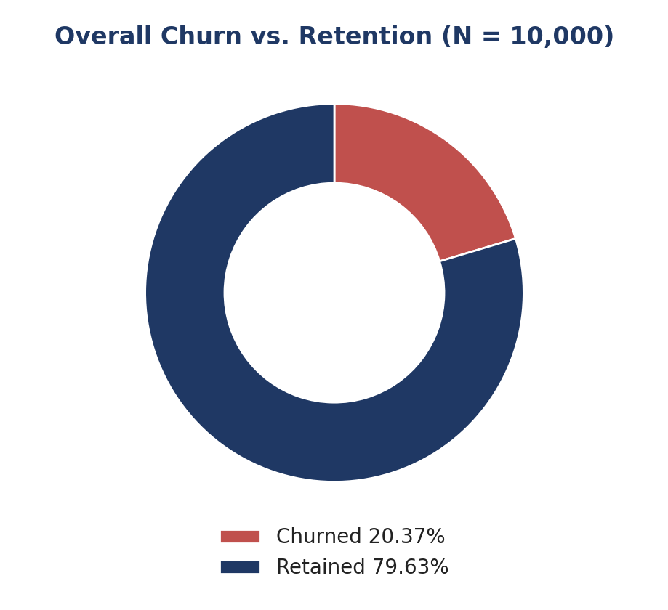
Figure 2. Overall churn versus retention across the full customer base of 10,000 records. [Analytical Figure (Generated from Verified Dataset)]
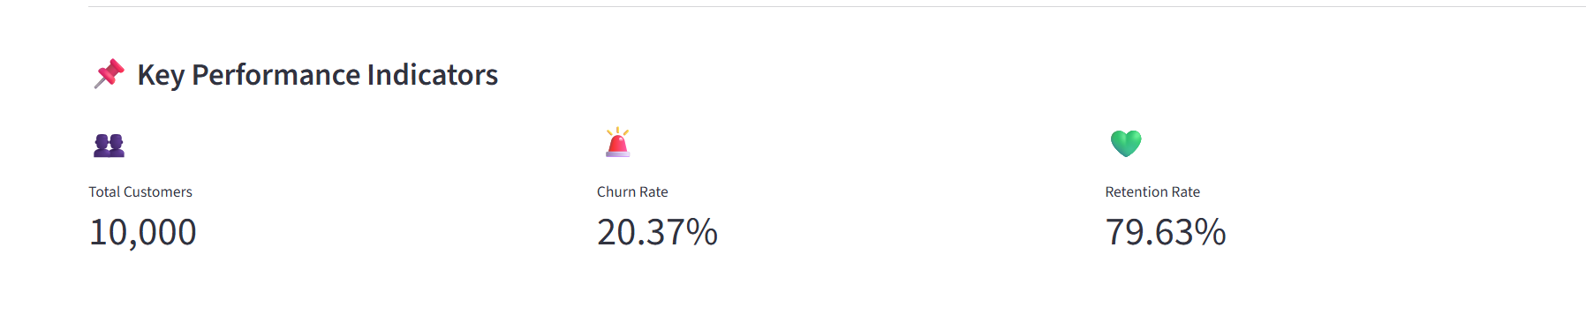
Figure 3. Main dashboard KPI panel showing total customers, churn rate, and retention rate. [Dashboard Screenshot (Streamlit Implementation)]

10. Customer Engagement Analysis
The conceptual basis for this section is shown in Figure 4, which frames engagement (IsActiveMember) as the branching variable against which observed churn and retention are compared.
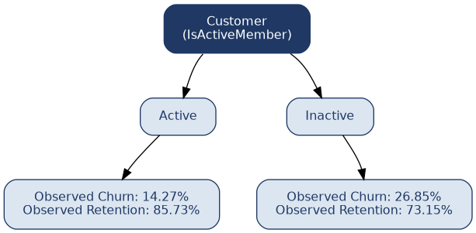
Figure 4. Customer engagement framework: Active/Inactive status branches into distinct observed churn and retention outcomes. [Conceptual Diagram]
The customer base is almost evenly split between active and inactive members, with 5,151 customers (51.51 percent) classified as active and 4,849 customers (48.49 percent) classified as inactive. Despite this near-even split in population, the two groups show a substantially different observed churn rate, as summarized in Table 3.
Engagement Status | Customers | Share | Observed Churn Rate
Active | 5,151 | 51.51% | 14.27%
Inactive | 4,849 | 48.49% | 26.85%
Table 3. Observed churn rate by customer engagement status.
Inactive customers show an observed churn rate of 26.85 percent compared with 14.27 percent for active customers, a difference of 12.58 percentage points. Expressed as a ratio, inactive customers show approximately 1.88 times the observed churn rate of active customers. Figure 5 presents this comparison graphically. This is the single largest bivariate gap identified across the behavioral variables examined in this study, and it is consistent with relationship-marketing literature suggesting that customer engagement mediates retention outcomes (Thach et al., 2025). The finding suggests, without implying a direct causal mechanism, that account activity is closely associated with a customer's likelihood of remaining with the bank, and that engagement status is a natural first-order lens for retention monitoring.
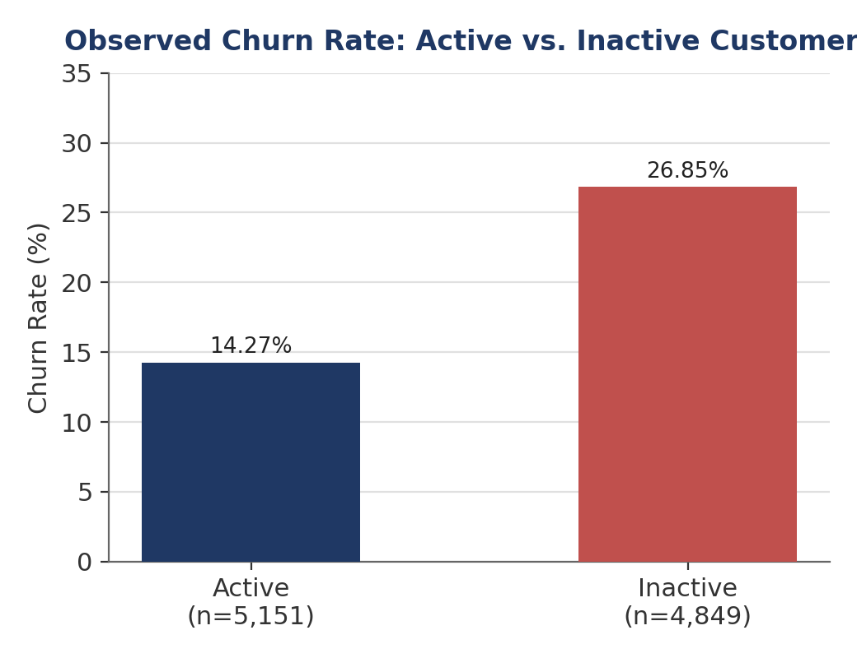
Figure 5. Observed churn rate for active versus inactive customers. [Analytical Figure (Generated from Verified Dataset)]

11. Product Utilization and Churn Analysis
Figure 6 frames the conceptual relationship examined in this section: number of products and customer engagement jointly determine a customer's relationship strength with the bank, which in turn is associated with the observed churn rate.
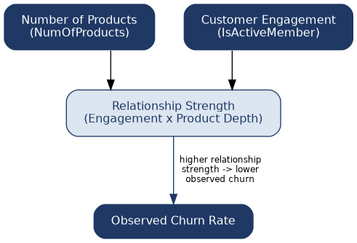
Figure 6. Product utilization framework: number of products and customer engagement combine into relationship strength, which relates to observed churn. [Conceptual Diagram]

11.1 Churn by Number of Products
Table 4 reports the observed churn rate by number of products held. The relationship is clearly non-monotonic: churn falls sharply between the one-product and two-product groups, then rises sharply for the three- and four-product groups.
Number of Products | Customers | Observed Churn Rate
1 | 5,084 | 27.71%
2 | 4,590 | 7.58%
3 | 266 | 82.71%
4 | 60 | 100.00%
Table 4. Observed churn rate by number of products held.
Two-product customers show the strongest observed retention among the major product groups, with a churn rate of only 7.58 percent compared with 27.71 percent for one-product customers. However, the three- and four-product groups contain only 266 and 60 customers respectively, far smaller than the 5,084 and 4,590 customers in the one- and two-product groups. Given this large difference in sample size, this study does not conclude that increasing product count always reduces churn, nor that three or four products are inherently associated with higher risk in a way that would generalize to a larger population; the very high churn rates in these small groups should be treated as an observation requiring further investigation with a larger sample rather than as an established pattern. Figure 7 and the corresponding dashboard screenshot in Figure 8 present this pattern graphically.
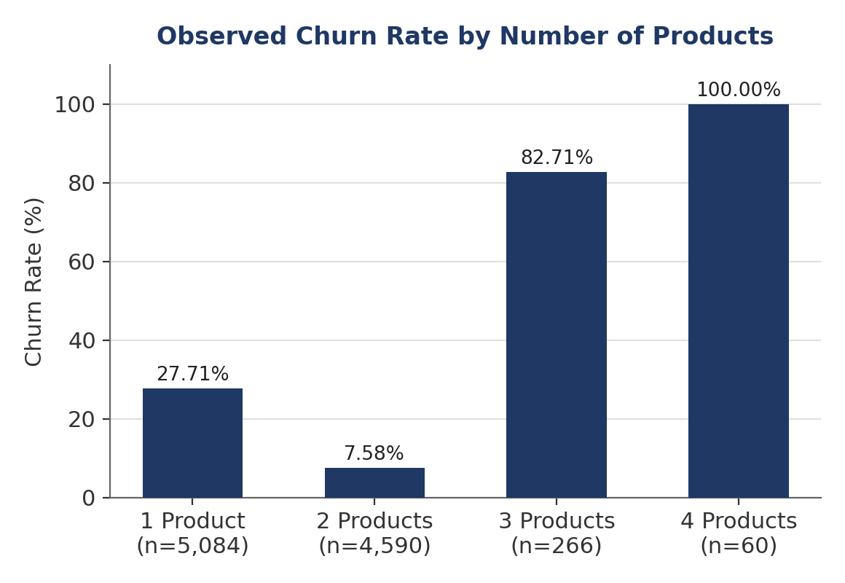
Figure 7. Observed churn rate by number of products held (1 to 4). [Analytical Figure (Generated from Verified Dataset)]
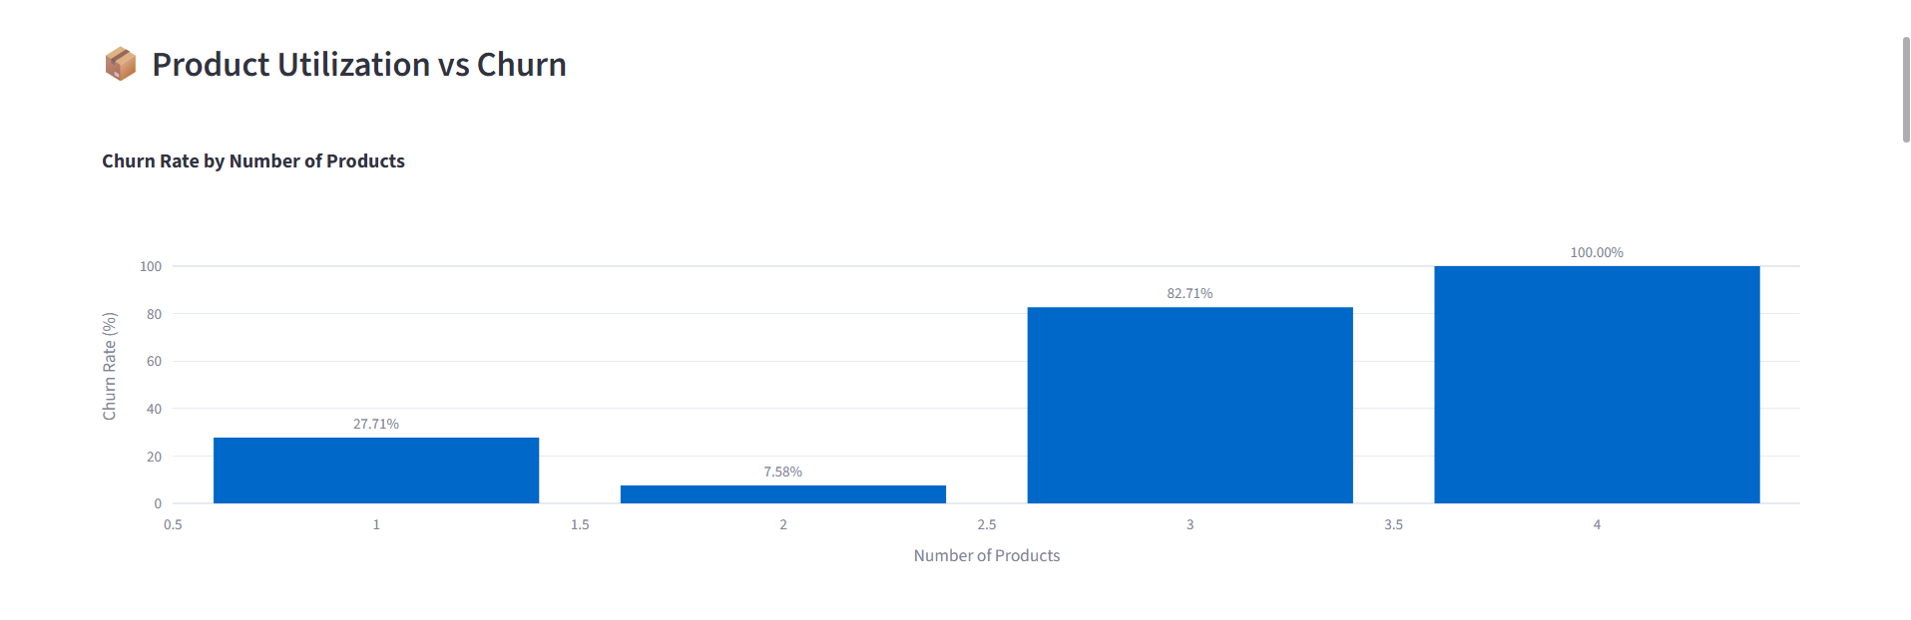
Figure 8. Dashboard view of churn rate by number of products, matching Table 4 and Figure 7. [Dashboard Screenshot (Streamlit Implementation)]

11.2 Interaction Between Product Utilization and Engagement
Table 5 breaks down churn by the combination of product count and engagement status, revealing that engagement moderates the churn rate within every product group.
Number of Products | Inactive Churn | Active Churn
1 | 36.65% | 18.92%
2 | 9.89% | 5.56%
3 | 88.24% | 75.22%
4 | 100.00% | 100.00%
Table 5. Observed churn rate by number of products, split by engagement status.
Within the one-product group, inactive customers churn at 36.65 percent compared with 18.92 percent for active customers. Within the two-product group, the gap narrows in absolute terms but the same direction holds, with inactive customers churning at 9.89 percent against 5.56 percent for active customers — meaning that active, two-product customers show the lowest observed churn of any product-engagement combination with a meaningful sample size. Within the three-product group, both inactive (88.24 percent) and active (75.22 percent) customers show high churn, and the four-product group shows 100 percent churn regardless of engagement status; both findings should again be read with the caution warranted by very small underlying samples (266 and 60 customers respectively). Considered together, these results suggest that engagement and product depth are not independent influences on churn but interact: the combination of low engagement and low product depth is associated with the highest churn among the larger, more reliable segments, while the combination of high engagement and moderate product depth is associated with the lowest. Figure 9 and the matching dashboard view in Figure 10 present this interaction graphically.
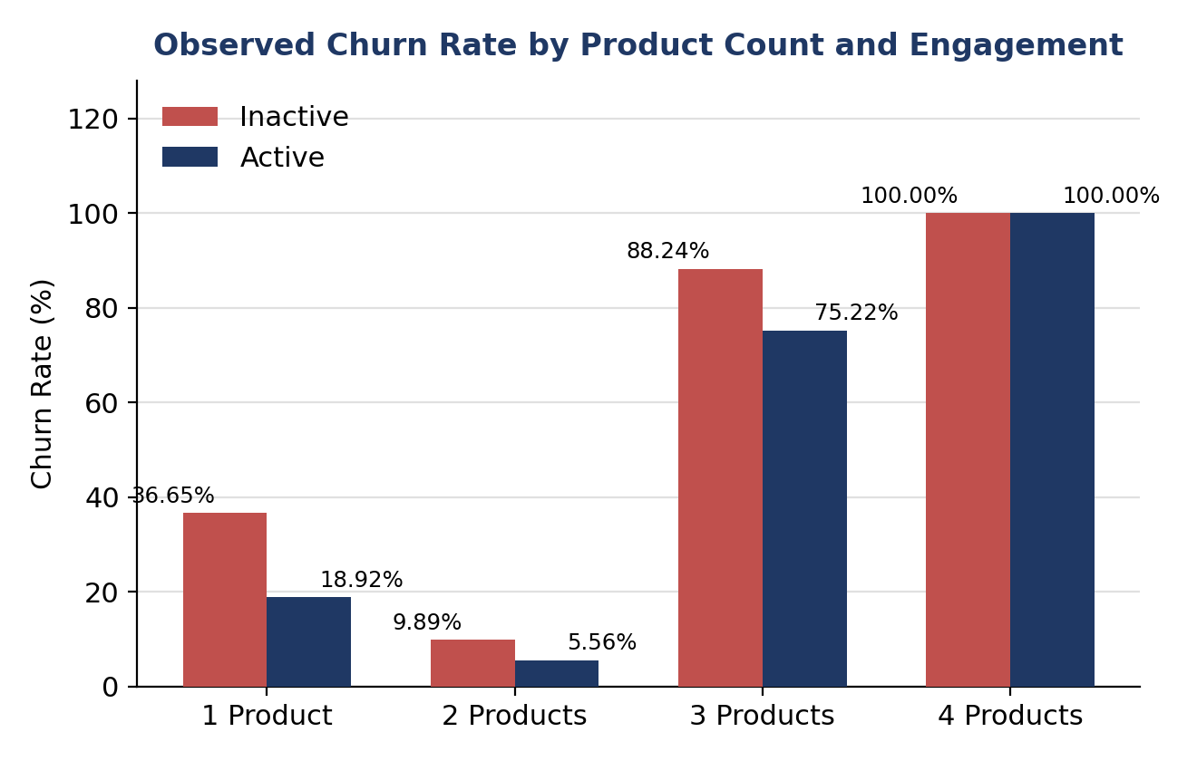
Figure 9. Observed churn rate by number of products, split by engagement status. [Analytical Figure (Generated from Verified Dataset)]
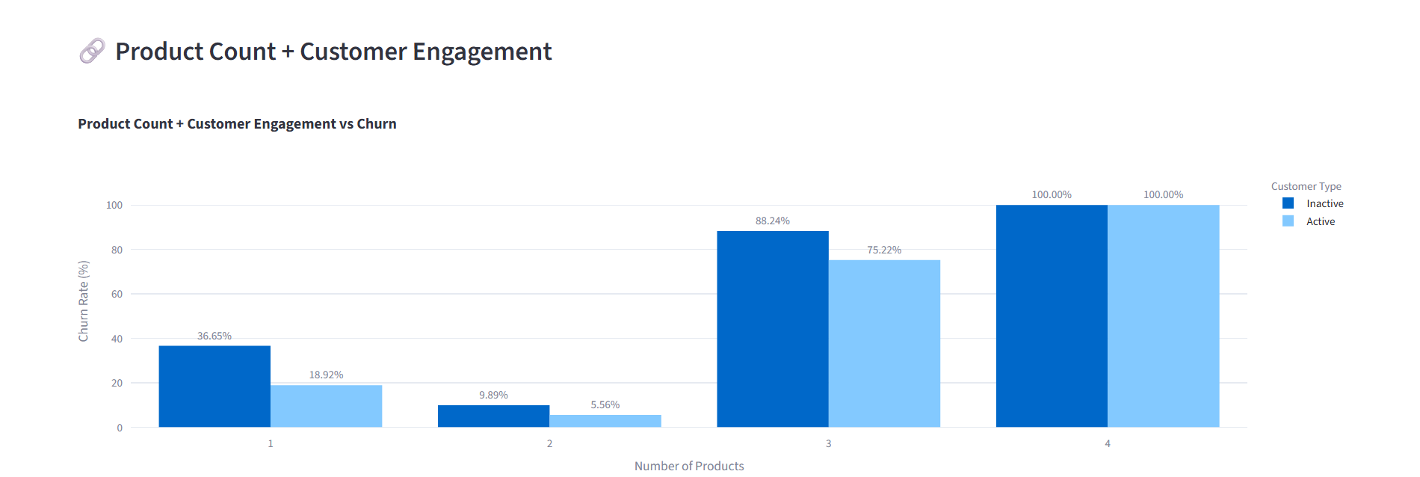
Figure 10. Dashboard view of churn rate by product count and engagement, matching Table 5 and Figure 9. [Dashboard Screenshot (Streamlit Implementation)]

12. High-Value Customer Risk Analysis

12.1 High-Balance Customers and Engagement
A high-balance threshold was defined at the 75th percentile of account balance, corresponding to ₹127,644.24. This threshold identifies 2,500 high-balance customers, of whom 1,247 are classified as inactive. Table 6 reports churn among high-balance customers split by engagement status.
Segment | Customers | Observed Churn Rate
High-Balance + Inactive | 1,247 | 30.47%
High-Balance + Active | 1,253 (approx.) | 16.92%
Table 6. Observed churn rate among high-balance customers, by engagement status.
High-balance, inactive customers churn at 30.47 percent compared with 16.92 percent for high-balance, active customers, a gap of 13.55 percentage points. Notably, the average balance among high-balance, inactive customers was approximately ₹148,524 for retained customers and approximately ₹149,619 for churned customers, a difference that is small relative to the overall balance level. This indicates that balance alone provides limited differentiation between retained and churned customers within this segment: it is engagement status, rather than the exact balance amount, that is more strongly associated with the churn gap observed among high-balance customers. Figure 11 presents this comparison graphically.
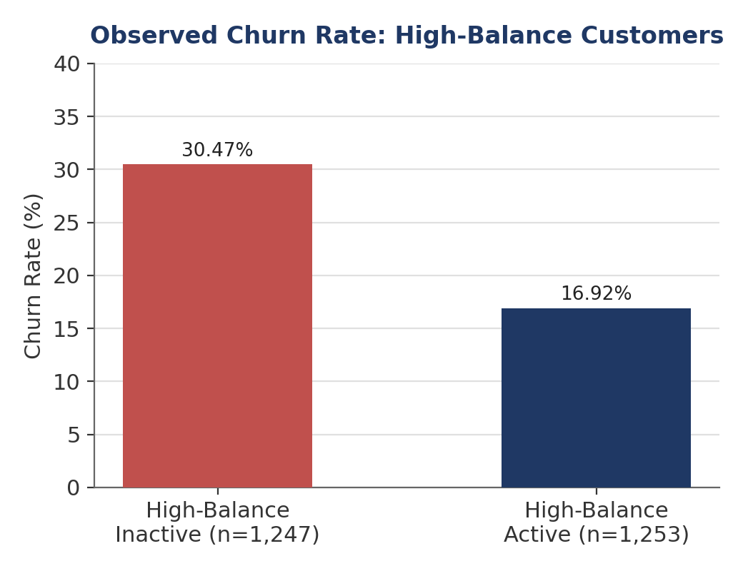
Figure 11. Observed churn rate among high-balance customers, by engagement status. [Analytical Figure (Generated from Verified Dataset)]

12.2 High-Value Risk Segment
Building on this observation, a more narrowly defined high-value risk segment was constructed using three joint conditions, illustrated in Figure 12: Balance at or above ₹127,644.24, IsActiveMember equal to 0, and Age of 44 years or above. This segment comprises 311 customers, or 3.11 percent of the total customer base, as summarized in Table 7.
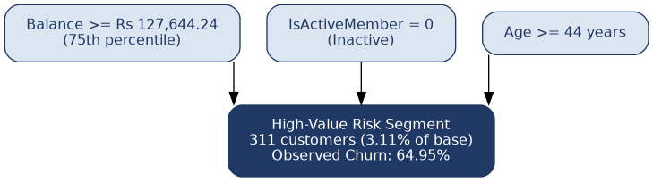
Figure 12. High-value risk identification framework: three joint conditions define the 311-customer high-value risk segment. [Conceptual Diagram]
Metric | Value
High-Value Risk Customers | 311
Customer Share of Total Base | 3.11%
Churned | 202
Retained | 109
Observed Churn Rate | 64.95%
Observed Retention Rate | 35.05%
Gap vs. Overall Churn Rate (20.37%) | +44.58 percentage points
Table 7. Composition and churn profile of the high-value risk segment (Balance ≥ ₹127,644.24, Inactive, Age ≥ 44).
The high-value risk segment shows an observed churn rate of 64.95 percent, 44.58 percentage points above the overall churn rate of 20.37 percent, despite representing only 3.11 percent of the customer base. This combination of small population share and disproportionately high churn is precisely the profile that a targeted retention program should prioritize, since intervention resources directed at this segment would be concentrated on customers who are both financially valuable and observably at elevated risk of leaving. Figure 13 and the corresponding dashboard view in Figure 14 present the churned-versus-retained composition of this segment.
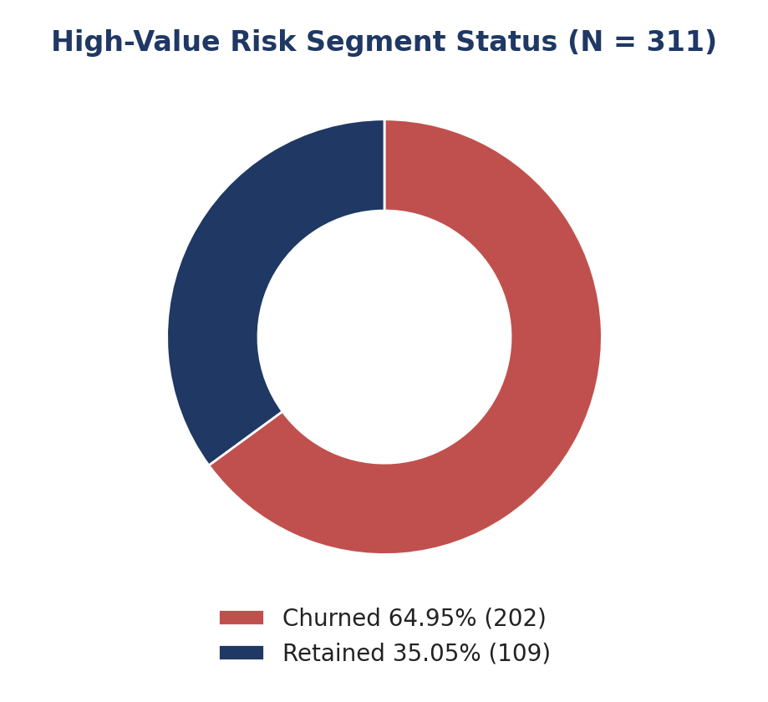
Figure 13. Churned versus retained composition of the high-value risk segment (N = 311). [Analytical Figure (Generated from Verified Dataset)]
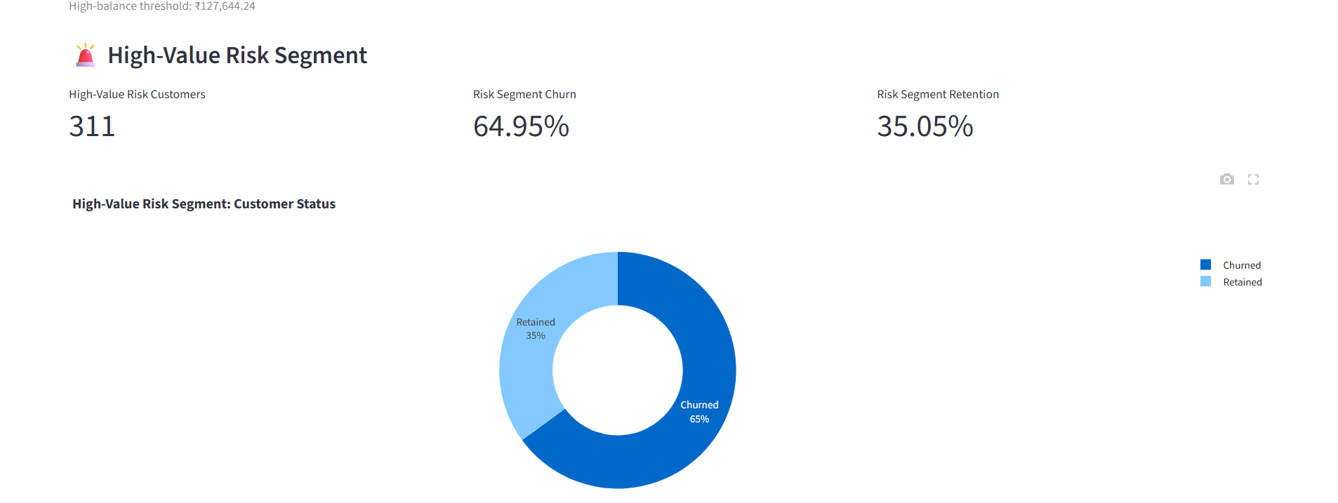
Figure 14. Dashboard view of the high-value risk segment composition, matching Table 7 and Figure 13. [Dashboard Screenshot (Streamlit Implementation)]

12.3 High-Value Risk Segment by Product Count
Number of Products | Customers | Observed Churn Rate
1 | 229 | 66.38%
2 | 62 | 48.39%
3 | 15 | 100.00%
4 | 5 | 100.00%
Table 8. High-value risk segment churn rate by number of products held.
Within the high-value risk segment, 229 of the 311 customers (73.63 percent) hold only one product, and this single-product subgroup shows a churn rate of 66.38 percent. Customers within this segment who hold two products show a somewhat lower, though still elevated, churn rate of 48.39 percent. The three- and four-product subgroups within this already-small segment contain only 15 and 5 customers respectively, and both show 100 percent churn; given these very small counts, these two figures should be read as descriptive observations rather than as generalizable findings. The concentration of the high-value risk segment in the single-product group suggests that under-utilization of the bank's product range, combined with low engagement and high balance, is strongly associated with elevated churn risk among older, financially valuable customers. Figure 15 and the matching dashboard view in Figure 16 present this breakdown graphically.
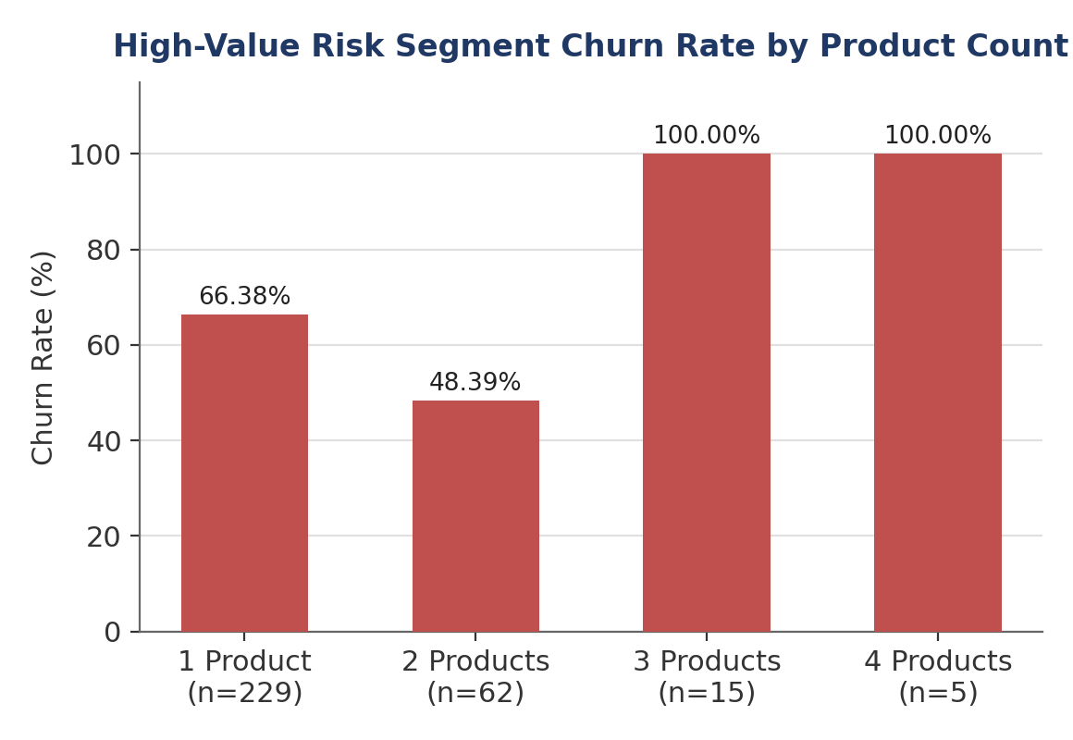
Figure 15. High-value risk segment churn rate by number of products held. [Analytical Figure (Generated from Verified Dataset)]
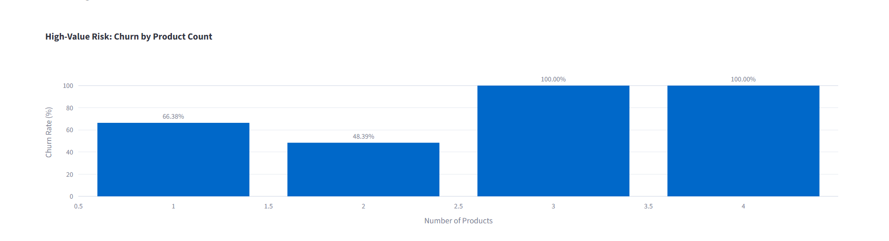
Figure 16. Dashboard view of high-value risk segment churn by product count, matching Table 8 and Figure 15. [Dashboard Screenshot (Streamlit Implementation)]

12.4 High-Value Risk Segment by Geography
Table 9 reports the overall churn rate by geography, followed by the churn rate within the high-value risk segment for each geography. Figures 17 and 18 present these two comparisons graphically; no dashboard screenshot documenting the geography view was available for inclusion in this report (see Section 8.7).
Geography | Overall Churn Rate | High-Value Risk Customers | High-Value Risk Churn Rate
France | 16.15% | 115 | 57.39%
Germany | 32.44% | 140 | 72.86%
Spain | 16.67% | 56 | 60.71%
Table 9. Overall and high-value risk segment churn rate by geography.
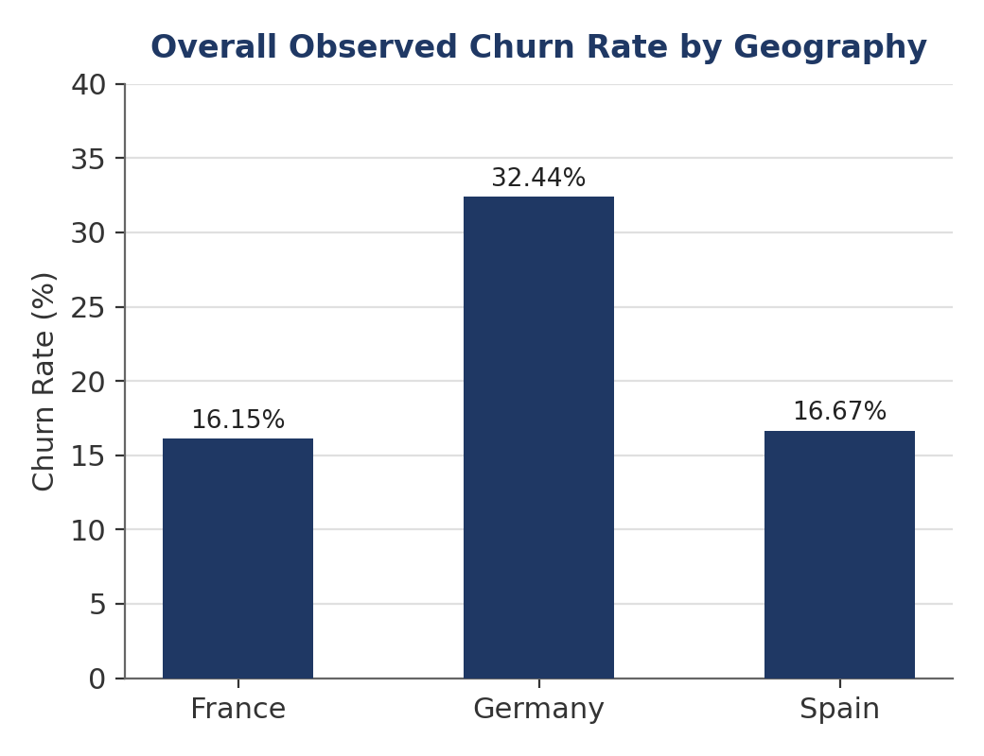
Figure 17. Overall observed churn rate by geography (France, Germany, Spain). [Analytical Figure (Generated from Verified Dataset)]
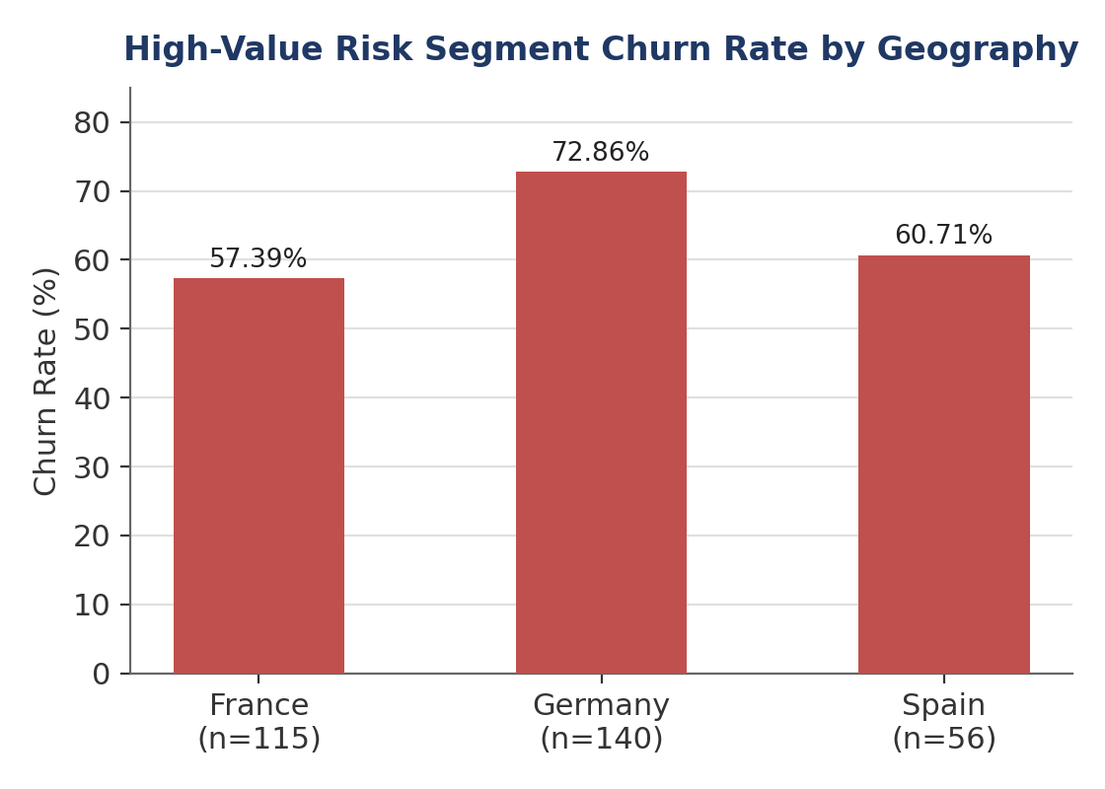
Figure 18. High-value risk segment churn rate by geography. [Analytical Figure (Generated from Verified Dataset)]
Germany shows the highest observed churn rate both overall (32.44 percent, roughly double the rate observed in France and Spain) and within the high-value risk segment (72.86 percent, the highest of the three geographies). Germany also contributes the largest number of high-value risk customers (140) among the three geographies, even though it does not have the largest overall customer base by geography. Together, these figures suggest that Germany warrants particular attention in any retention strategy that accounts for geographic risk concentration, though the underlying reasons for the elevated German churn rate cannot be determined from this dataset alone and would require further investigation, for example into local competitive conditions or service delivery differences.

13. Relationship Strength Analysis
To complement the risk-focused segments defined in Section 12, a relationship-strength segment was defined to identify customers who represent the strongest observed retention profile in the dataset: customers with IsActiveMember equal to 1 (active) and NumOfProducts equal to 2. This segment comprises 2,446 customers, or 24.46 percent of the total customer base, as summarized in Table 10.
Metric | Value
Active + 2 Products Customers | 2,446
Customer Share of Total Base | 24.46%
Observed Churn Rate | 5.56%
Observed Retention Rate | 94.44%
Overall Retention Rate (baseline) | 79.63%
Gap vs. Overall Retention Rate | +14.81 percentage points
Relationship Strength Index | 118.60
Table 10. Composition and retention profile of the relationship-strength segment (Active, 2 Products).
This segment shows an observed retention rate of 94.44 percent, 14.81 percentage points above the overall retention rate of 79.63 percent, corresponding to a Relationship Strength Index of 118.60 (that is, this segment retains customers at roughly 118.6 percent of the overall baseline rate). Because this segment also represents close to a quarter of the entire customer base (24.46 percent), it is not a small or unusual subgroup but a substantial, statistically credible portion of the customer population. Figure 19 and the matching dashboard view in Figure 20 present this retention comparison graphically. This is consistent with relationship-marketing findings that a stronger, more actively engaged customer-bank relationship is associated with more favorable relational outcomes (Al-Wugayan, 2021), and it reinforces engagement combined with a moderate (rather than minimal or excessive) product depth as the profile most strongly associated with retention in this dataset.
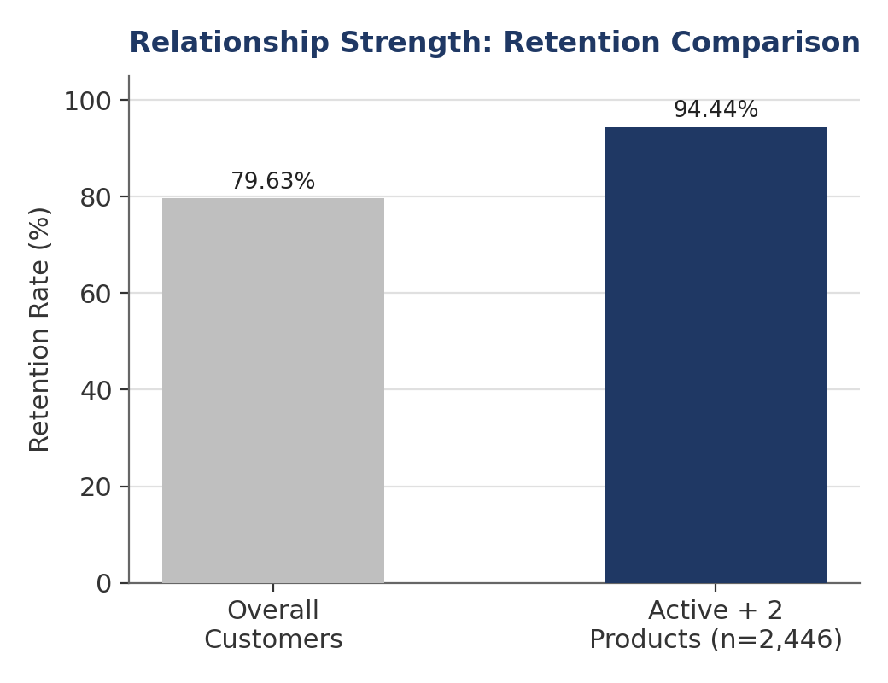
Figure 19. Retention rate comparison: overall customer base versus the active, two-product relationship-strength segment. [Analytical Figure (Generated from Verified Dataset)]
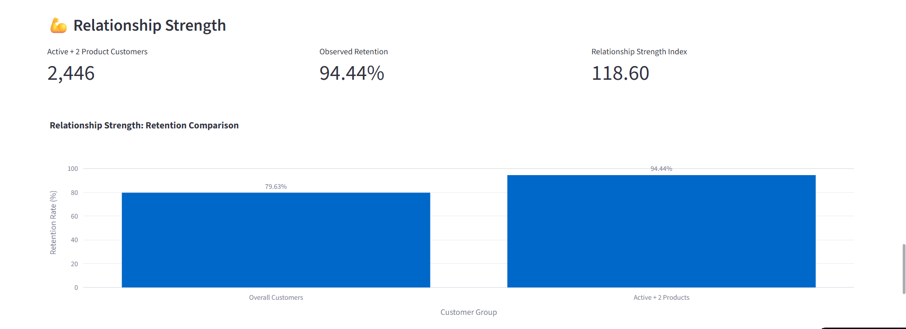
Figure 20. Dashboard view of the relationship strength retention comparison, matching Table 10 and Figure 19. [Dashboard Screenshot (Streamlit Implementation)]

14. Key Performance Indicators
This section consolidates the key performance indicators used throughout the paper into a single reference framework. Each KPI is defined with its calculation method and its connection to the findings reported in Sections 9 through 13. Figure 21 situates this KPI framework within the broader analytical logic of the study, in which customer behavior, product utilization, financial value, and engagement jointly feed into risk segmentation and, ultimately, retention strategy.
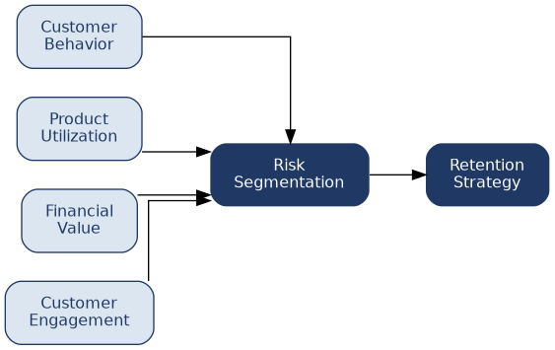
Figure 21. Overall customer retention analytical framework: customer behavior, product utilization, financial value, and engagement feed into risk segmentation and retention strategy. [Conceptual Diagram]
KPI | Calculation | Observed Value
Overall Churn Rate | Churned customers ÷ Total customers | 20.37%
Overall Retention Rate | Retained customers ÷ Total customers (or 1 − Churn Rate) | 79.63%
High-Balance Disengagement Rate | High-balance inactive customers ÷ High-balance customers | 49.88% (1,247 ÷ 2,500)
High-Balance + Inactive Churn Rate | Churned customers within high-balance, inactive group ÷ High-balance, inactive customers | 30.47%
High-Value Risk Churn Rate | Churned customers within high-value risk segment ÷ High-value risk segment size | 64.95%
High-Value Risk Customer Share | High-value risk segment size ÷ Total customers | 3.11%
Credit Card Stickiness Score | (Retention rate of active + credit-card customers ÷ Overall retention rate) × 100 | 108.80
Relationship Strength Index | (Retention rate of active, 2-product segment ÷ Overall retention rate) × 100 | 118.60
Product Depth Comparison | Churn rate by number of products (1 vs. 2 vs. 3 vs. 4) | 27.71% / 7.58% / 82.71% / 100.00%
Table 11. Key performance indicator framework with calculation methods and observed values.
The Overall Churn Rate and Overall Retention Rate serve as the baseline against which every other KPI in this framework is compared. The High-Balance Disengagement Rate quantifies what share of financially valuable customers are also behaviorally disengaged, providing an early warning indicator distinct from churn itself. The High-Balance + Inactive Churn Rate and High-Value Risk Churn Rate move from a leading indicator (disengagement) to a lagging outcome indicator (actual observed churn) within increasingly narrowly defined valuable-customer segments. The High-Value Risk Customer Share indicates how large a targeted retention program would need to be to cover this segment, which in this dataset is a manageable 3.11 percent of the base. The Credit Card Stickiness Score and Relationship Strength Index are both expressed as an index relative to 100, where the overall retention rate is normalized to 100; a value above 100 indicates that a segment retains customers at a better-than-average rate. Finally, the Product Depth Comparison is retained as a KPI in its own right, precisely because it is non-monotonic and therefore cannot be reduced to a single number without losing important information about the two small, high-churn product segments.

15. Results and Discussion
Bringing together the findings from Sections 9 through 14, three broad patterns emerge from this analysis. First, customer engagement is the single strongest bivariate behavioral factor associated with churn in this dataset: inactive customers churn at close to 1.88 times the rate of active customers, and this gap persists, in a moderated form, within every product-count group examined in Section 11.2. This suggests that engagement-focused interventions — such as encouraging account usage or re-engaging dormant customers — are likely to be a foundational element of any retention strategy built from this data, independent of which other segment a customer falls into.
Second, product utilization shows a genuinely non-monotonic relationship with churn that cannot be summarized as “more products, less churn” or the reverse. Two products is associated with the lowest observed churn among the segments with adequate sample size, while both one product (under-utilization) and three-or-more products (a much smaller, harder-to-interpret group) are associated with higher observed churn. The high-value risk segment analysis in Section 12.3 reinforces this: nearly three-quarters of high-value risk customers hold only a single product, suggesting that under-utilization, not over-utilization, is the more actionable and statistically reliable signal in this dataset.
Third, layering financial value and geography onto the engagement and product-depth findings identifies two segments at opposite ends of the retention spectrum: a high-value risk segment (3.11 percent of the base, 64.95 percent churn, concentrated in single-product and German customers) and a relationship-strength segment (24.46 percent of the base, 94.44 percent retention, defined by active engagement and two-product depth). The existence of a retention gap of nearly 60 percentage points between these two segments (64.95 percent churn versus 5.56 percent churn) illustrates how much variation in outcomes is masked by the single overall churn rate of 20.37 percent, and underscores the practical value of a segment-aware retention framework over a single aggregate metric.
The credit card ownership analysis (20.81 percent churn without a card versus 20.18 percent with one, a difference of only 0.63 percentage points) stands in contrast to these findings and serves as a useful negative result: not every plausible behavioral variable is strongly associated with churn in this dataset. Credit card ownership on its own is a weak differentiator, and its apparent value in the Credit Card Stickiness Score (108.80) only becomes meaningful when combined with active engagement, again reinforcing engagement as the more central behavioral construct relative to any single product feature considered in isolation. Figure 22 presents this retention comparison graphically; as noted in Section 8.7, no dashboard screenshot documenting this specific view was available for inclusion in this report.
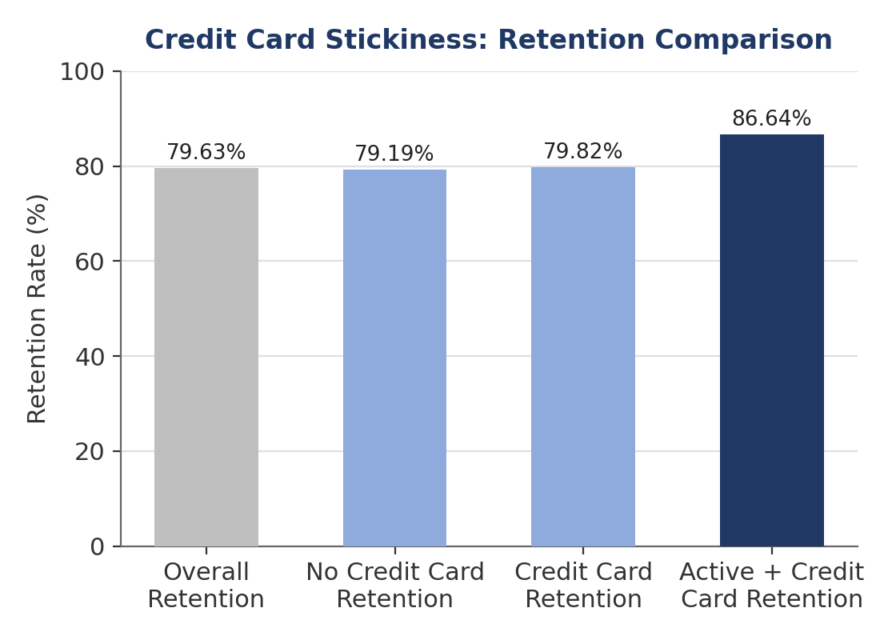
Figure 22. Retention rate comparison across overall customers, credit card ownership status, and the active-plus-credit-card segment underlying the Credit Card Stickiness Score. [Analytical Figure (Generated from Verified Dataset)]

16. Business Recommendations
Based strictly on the observed, associative relationships reported in this study, the following recommendations are proposed for consideration by retention and relationship-management teams. These are framed as candidate actions to evaluate and test, not as guaranteed outcomes, since the underlying data is observational and does not establish causation.
- Prioritize re-engagement outreach toward inactive customers generally, given that inactive status is associated with the largest single behavioral churn gap identified in this study (12.58 percentage points versus active customers).
- Treat the 311-customer high-value risk segment (high balance, inactive, age 44 and above) as a dedicated, high-priority retention list, given its observed 64.95 percent churn rate against a 3.11 percent share of the base — a small, manageable list with a disproportionately large potential retention payoff.
- Within the high-value risk segment, focus specifically on single-product customers, since they represent 73.63 percent of the segment and show a 66.38 percent churn rate; consider reviewing why these otherwise valuable customers have not adopted additional products or services.
- Give Germany specific attention in retention planning, given its markedly higher overall churn rate (32.44 percent) and its highest-in-sample high-value risk churn rate (72.86 percent) among the three geographies studied.
- Consider strategies to move customers from one product to two products, since two-product customers show the strongest observed retention among the major product groups; however, avoid targets or incentives that push customers toward three or four products purely to increase product count, since the very high churn observed in those groups may reflect specific circumstances that are not yet understood and are based on small sample sizes.
- Treat the 2,446-customer active, two-product segment as a reference relationship profile: monitor whether newly engaged or newly cross-sold customers are moving toward this profile over time, using the Relationship Strength Index as a tracking metric.
- Do not rely on credit card ownership alone as a retention lever, given its weak observed differentiation (0.63 percentage points); it may still be useful in combination with engagement-focused programs, as reflected in the Credit Card Stickiness Score.

17. Limitations
This study has several limitations that should be considered when interpreting its findings. First, the dataset is cross-sectional rather than longitudinal: it captures a snapshot of customer status rather than tracking individual customers over time, which means that no causal or temporal claims can be made about why a customer became inactive or churned, only that these states are associated with one another.
- The three-product (266 customers) and four-product (60 customers) segments are considerably smaller than the one- and two-product segments, and all findings involving these groups, including their interaction with engagement, high-value risk status, and geography, should be treated as preliminary observations rather than robust, generalizable conclusions.
- The dataset does not include transaction-level detail, customer service interaction history, or product-specific usage intensity, which would allow a more granular understanding of why engagement or product depth relate to churn as they do.
- The analysis is descriptive and diagnostic rather than predictive; it does not build or validate a churn prediction model, and the relationships reported should not be interpreted as sufficient on their own to score or rank individual customers for intervention.
- The dataset originates from a single institution and set of geographies (France, Germany, and Spain); the specific magnitudes reported here may not generalize to banks operating in different markets or under different product structures.
- No controlled experiment or A/B test underlies these findings; consequently, the business recommendations in Section 16 should be treated as hypotheses to test, not as validated interventions.

18. Future Scope
Several directions could extend this study. The descriptive and diagnostic framework developed here could be combined with a predictive model, of the kind reviewed in Section 5.1, to move from identifying which segments are at risk to scoring individual customers within those segments for prioritized outreach. Incorporating transaction-level and customer-service interaction data would allow the engagement construct to be measured with greater granularity than the binary active/inactive flag used in this dataset, potentially revealing gradations of engagement that are currently collapsed into a single category.
A longitudinal extension of this dataset, tracking the same customers over multiple periods, would allow the high-value risk and relationship-strength segments defined in this study to be validated as leading indicators, observing whether customers who enter the high-value risk profile do subsequently churn at elevated rates, and whether customers who move into the relationship-strength profile see improved retention going forward. Finally, given the very small sample sizes of the three- and four-product segments in the present dataset, a larger, multi-institution dataset would help determine whether the sharp increase in churn observed at higher product counts here is a genuine, generalizable pattern or an artifact specific to this dataset.

19. Conclusion
This study analyzed a dataset of 10,000 banking customers to examine how customer engagement, product utilization, financial value, and relationship depth relate to observed churn and retention outcomes, deliberately favoring a behavioral and relationship-based lens over demographic profiling. The analysis found that customer engagement is the single strongest bivariate behavioral factor associated with churn (a 12.58 percentage point gap between active and inactive customers), that product utilization shows a non-monotonic relationship with churn that must be interpreted cautiously for the small three- and four-product segments, and that combining engagement, product depth, financial value, and geography identifies both a small but critical high-value risk segment (3.11 percent of customers, 64.95 percent churn) and a substantial relationship-strength segment (24.46 percent of customers, 94.44 percent retention).
The paper's main contribution is a behavioral and relationship-based framework — expressed through a compact set of key performance indicators including the High-Value Risk Churn Rate, the Credit Card Stickiness Score, and the Relationship Strength Index — that translates these observed relationships into a form that a bank's retention function could monitor and act on directly. All findings are presented as observed, associative relationships rather than causal claims, and segments with small underlying sample sizes have been flagged explicitly throughout, in keeping with the observational and cross-sectional nature of the underlying dataset.

References
Alizadeh, M., Zadeh, D. S., Moshiri, B., & Montazeri, A. (2023). Development of a customer churn model for banking industry based on hard and soft data fusion. IEEE Access, 11, 29759–29768. https://doi.org/10.1109/ACCESS.2023.3257352
Al-Najjar, D., Al-Rousan, N., & Al-Najjar, H. M. (2022). Machine learning to develop credit card customer churn prediction. Journal of Theoretical and Applied Electronic Commerce Research, 17(4), 1529–1542. https://doi.org/10.3390/jtaer17040077
Al-Wugayan, A. A. (2021). Customer relationships in banking: Does relationship strength influence relationship quality and outcomes? Studies in Business and Economics. https://doi.org/10.29117/sbe.2020.0121
Bharathi, S. V., Pramod, D., & Raman, R. (2022). An ensemble model for predicting retail banking churn in the youth segment of customers. Data, 7(5), 61. https://doi.org/10.3390/data7050061
de Lima Lemos, R. A., Silva, T. C., & Tabak, B. M. (2022). Propension to customer churn in a financial institution: A machine learning approach. Neural Computing and Applications, 34, 11751–11768. https://doi.org/10.1007/s00521-022-07067-x
Rudd, D. H., Huo, H., & Xu, G. (2022). Improved churn causal analysis through restrained high-dimensional feature space effects in financial institutions. Human-Centric Intelligent Systems, 2, 70–80. https://doi.org/10.1007/s44230-022-00006-y
Thach, N. H., Ghi, T. N., Khoi, B. H., Thanh, P. T. K., & Ngoc, P. T. H. (2025). Social customer relationship management and customer lifecycle value in banking: The mediating and moderating roles of engagement. Banks and Bank Systems, 20(3), 129–144. https://doi.org/10.21511/bbs.20(3).2025.10
Vu, V.-H. (2023). Predict customer churn using combination deep learning networks model. Neural Computing and Applications, 36(9), 4867–4883. https://doi.org/10.1007/s00521-023-09327-w
Vu, V.-H. (2024). An efficient customer churn prediction technique using combined machine learning in commercial banks. Operations Research Forum, 5, 1–20. https://doi.org/10.1007/s43069-024-00345-5

